LibertyCon 2021 – Freedom Road: The Struggle for Justice Continues
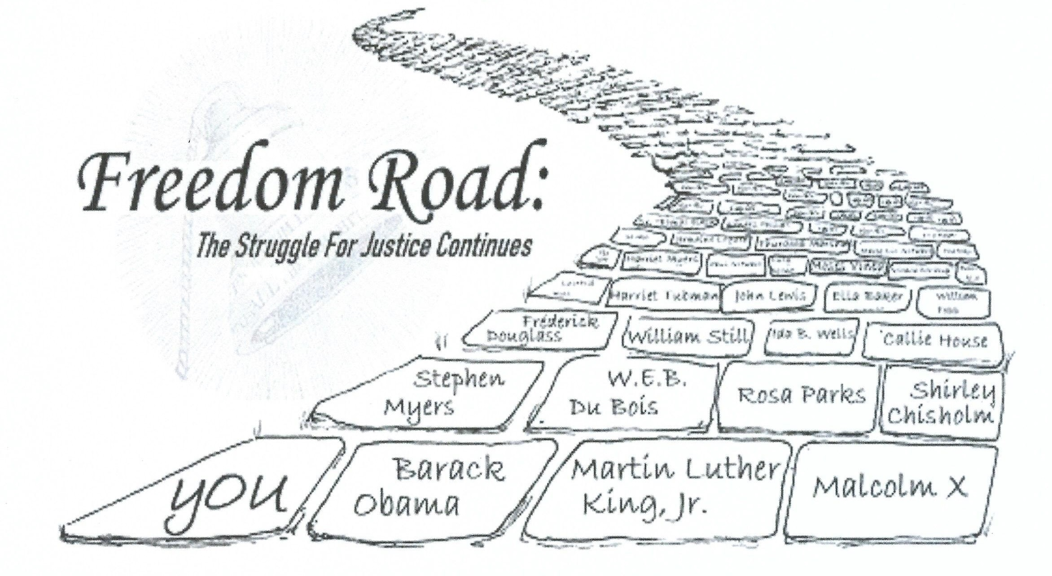
May 3, 2021 Planning meeting
Attending – Julia Holcomb, Chris Cummings, Deb Abel, David Hochfelder,
Willie Terry, Brenda Twiggs, Paul Stewart, Mary Liz Stewart

Agenda items:
(1) Renaming
(2) Raffle – how to manage

Conversations led to the following decisions
(1) Renaming – - options considered included LiberationCon, FreedomCon, Albany’s Underground Railroad History Conference, LibertyMatters, FreedomCon
- selection agreed to – FreedomCon
There are no recordings of FreedomCon in the US Patent and Trademark Office

(2) Raffle – paper vs online --- pay vs giveaway --- connect to taking out a subscription membership
Following conversation, the following was agreed to –
- we will make raffle tickets available via paper and online
- we will add an online component of ‘take out a subscription membership and receive a free raffle ticket’
- raffle tickets will be $5 each or 3 for $10
- online purchasers will have their name applied to a paper ticket
- paper tickets will be collected in and pulled from our raffle drum
- the raffle winners will be drawn at the conclusion of the July and November presentations

- Mary Liz will arrange for online raffle ticket set up, print out and delivery of paper tickets
- Mary Liz will make sure all raffle ticket purchases will have a paper raffle ticket(s) added to collection in the name of the purchase
- Mary Liz will work with website designer to set up online raffle ticket purchase – may ask for an additional LibertyCon page that is a Raffle page that contains pictures of prizes and availability of online tickets
- Mary Liz will invite the over 3000 Constant Contact recipients to purchase raffle tickets
- Everyone will be asked to promote sale of paper tickets

NEXT MEETING – MONDAY, JUNE 7 AT 5:30PM

You are invited to a Zoom meeting.
When: Jun 7, 2021 05:30 PM Eastern Time (US and Canada)

Register in advance for this meeting:
https://us02web.zoom.us/meeting/register/tZAuce2rrDsiEtBCFWEJKzmLOGP4U0Ms6DK4

After registering, you will receive a confirmation email containing information about joining the meeting.

